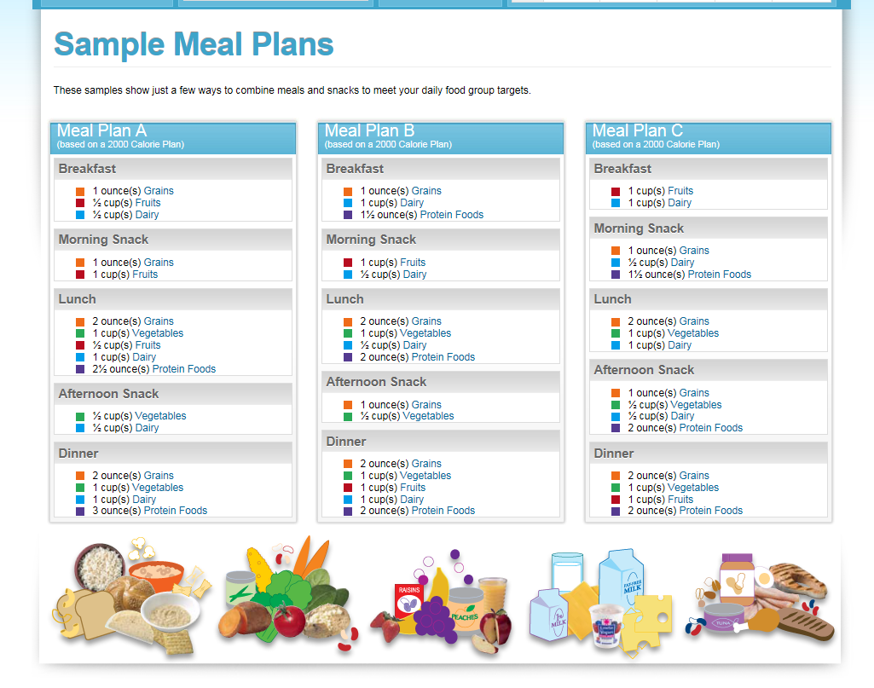
https://supertracker.usda.gov/samplemealplans.aspx

